**Experiment-2 Study of Different Network Topologies**

ECP316 (Communication Networks)

Polastee Bhoi (BT23EEE042)

**Aim:** To Study different types of Network Topologies.

**Tools Used:** Cisco Packet Tracer

**Theory:**

**Bus Topology**: In a bus topology, all devices are connected to a single central cable, known as the bus. Data sent from one device travels along the bus until it reaches its destination. It is simple to install and uses less cable, but a fault in the central cable can disrupt the entire network.

**Ring Topology**: In a ring topology, each device is connected to two other devices, forming a circular pathway for data. Data travels in one direction (or both, in a dual ring) around the ring until it reaches its destination. It's easy to install, but failure in any single device can affect the entire network.

**Star Topology**: In a star topology, all devices are connected to a central hub or switch. Data from any device goes to the hub, which then directs it to its destination. It's highly reliable because a fault in one cable doesn't affect others, but the hub's failure can disrupt the whole network.

**Mesh Topology**: In a mesh topology, every device is connected to every other device. This creates multiple pathways for data, ensuring robust redundancy and fault tolerance. If one path fails, data can take an alternate route. However, it requires a lot of cabling and is complex to install and manage.

**Procedure:**

1. Open Cisco Packet Tracer application on computer.
2. Use PCs and give them IP addresses as 192.168.1.x; where x can be any number between 0-255.
3. Use PT Switch only as they’re already defined according to our use.
4. Use RJ45 Cables to connect the PCs and switches as according to the topology diagram. We can check the connections using ping in the command prompt of each PC.
5. Try sending mail from one PC to another and start simulation and observe.

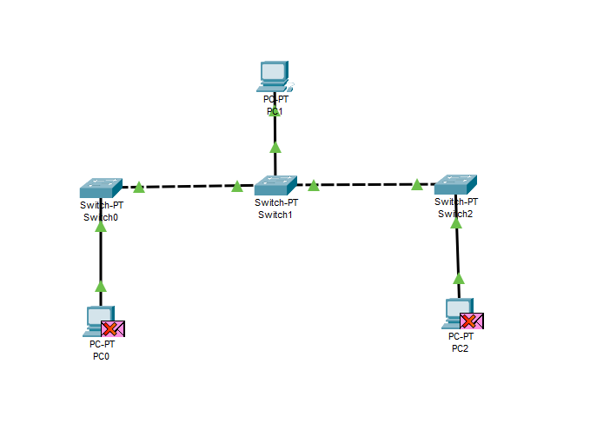**Observations;**

**Bus Topology**

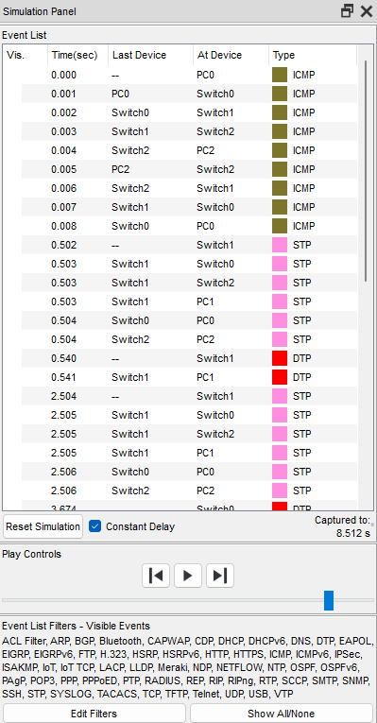

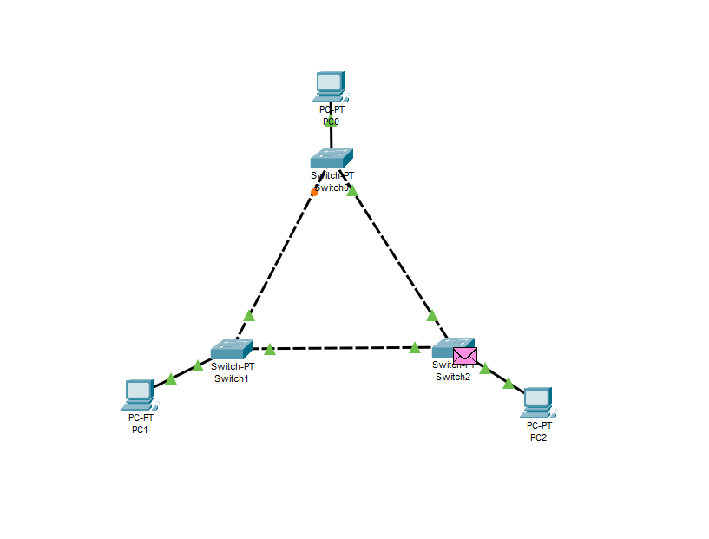**Ring Topology**

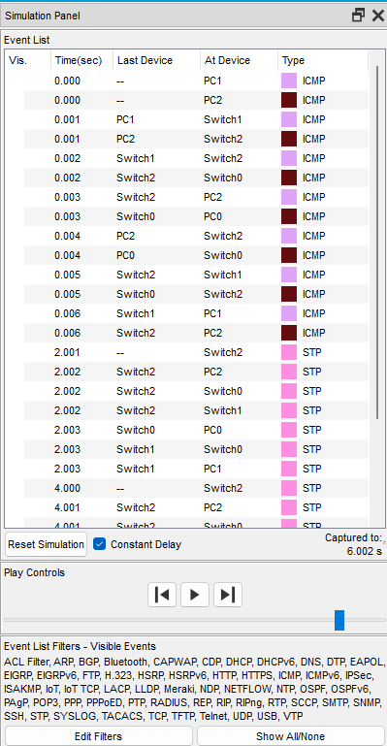

**Star Topology**

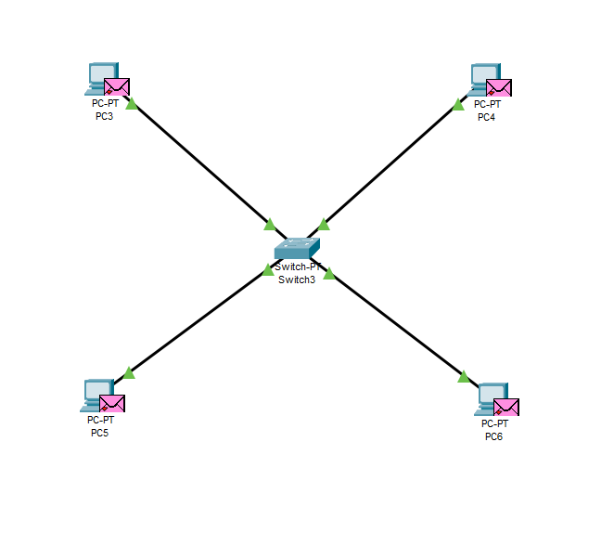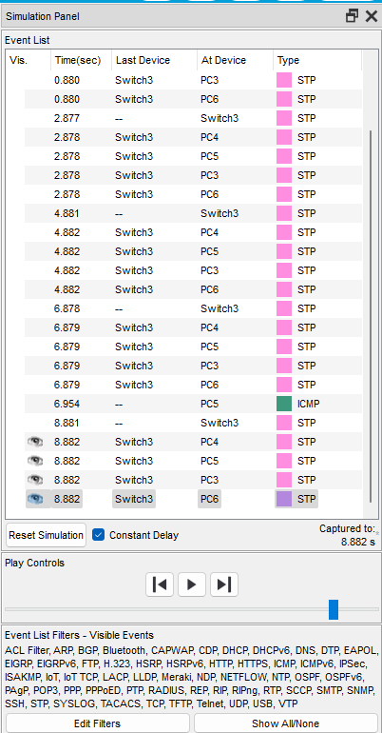

**Mesh Topology**

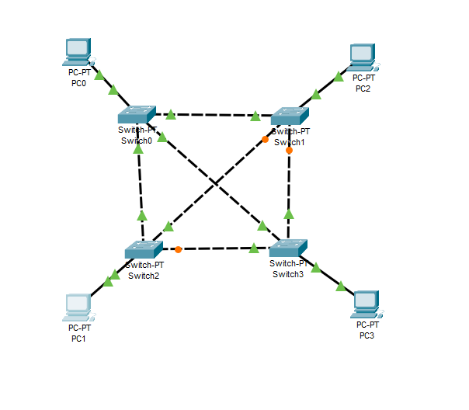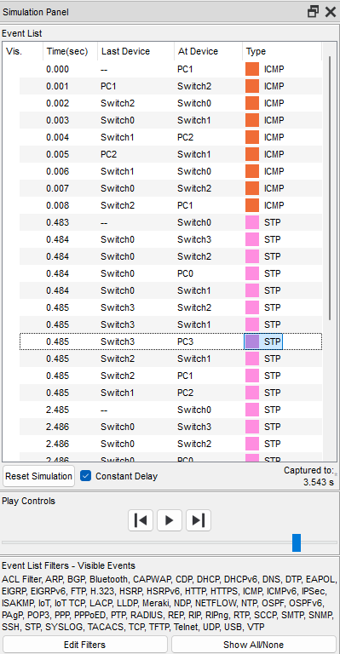

**Connection checking for anyone of the PC**

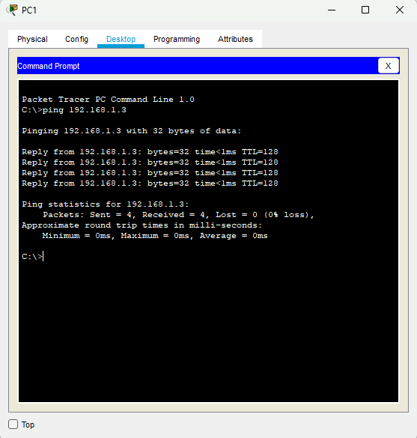

**Checking Wrong IP Connection in**

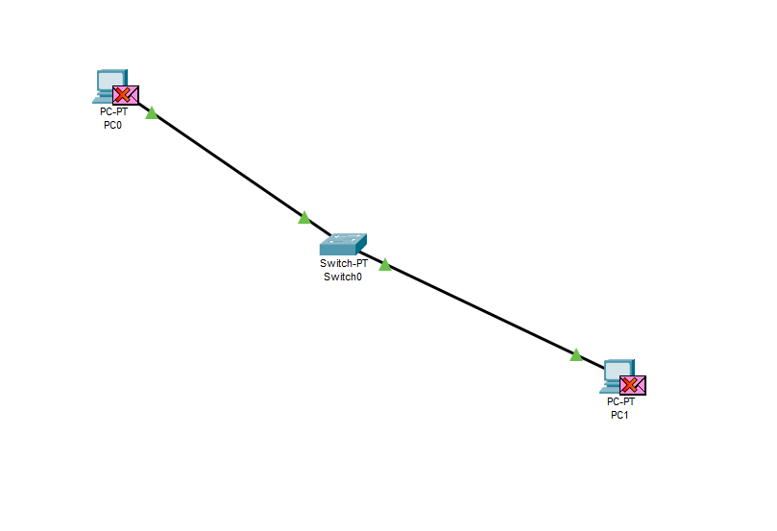

**PC0 PC1**

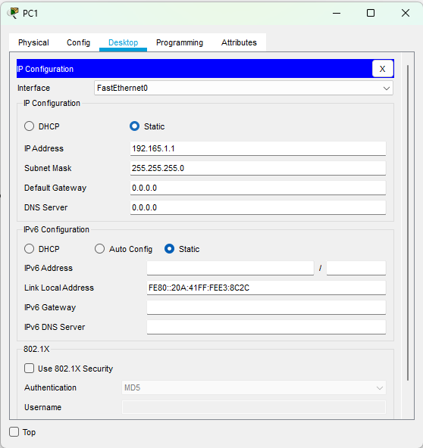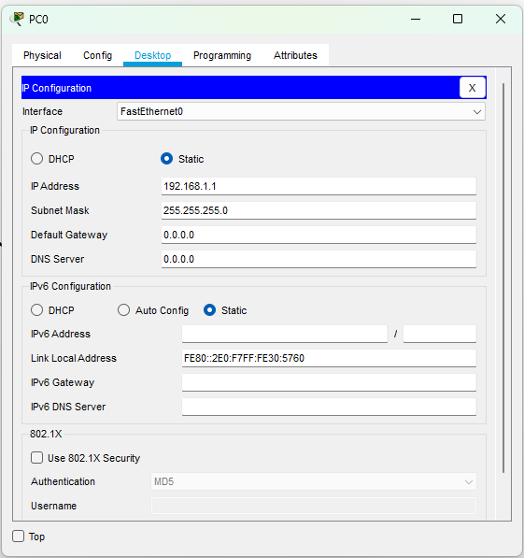

**Message Checking**

Message not transferred due to lack of proper IP (i.e. Connection).

**Result and Conclusion:**

* In this analysis, we examined different network topologies: Bus, Ring, Star, and Mesh. Each topology has its own set of advantages and challenges.
* Bus and Ring topologies are straightforward but more susceptible to failures, whereas Star topology simplifies troubleshooting but depends heavily on a central hub.
* Although Mesh topology is more intricate, it delivers exceptional fault tolerance and reliability.
* Grasping these topologies is essential for designing networks that meet specific needs and resilience goals.

